Test Report and Result Document

Motorola Deep Connect

*Date: 22-05-2024*

**Owner: Morphedo Technologies Pvt Ltd**

# Test Objective:

*To test the functionality of the DTMF IC and the 16*2 LCD screen*

**Test Summary:**

**This test will be performed to ensure that the DTMF module is working as intended. This test requires an extra walkie talkie which will be interacting with the DEEP CONNECT BOX. The Walkie talkie will be sending the DTMF tones to the box and same will be cross checked on the display.**

# Components Used:

## DEEP CONNECT BOX

Walkie Talkie

# Test Setup:

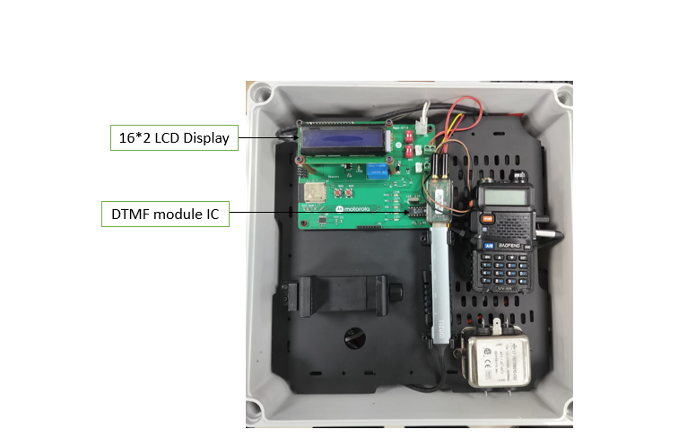

Fig 1

# Test Procedure:

# Steps:

1. Power up the device by connecting the power connector to the female port and turn on all the switches in the box.

2. Turn on the walkie talkies and match their frequencies.

3. Adjust the volume level on the walkie talkie inside the box. Make sure the volume level is adjusted to the min and do it by observing the LEDs on board which react different with different tones.

4. As the volume adjustments are made, Press the PTT button on the hand-held walkie talkie and press any number value.

5.Now the pressed number value must be displayed on the screen

# Observation Table:

|  |  |  |
| --- | --- | --- |
| **Sno.** | **Observation** | **Output Images** |
|  | *Output when pressing 1* |  |
|  | *Output when pressing 0* |  |
|  | *Output when pressing \** |  |
|  | *Output when pressing 2* |  |
|  | *Output when pressing 8* |  |

# Result & Conclusion:

*As per the observations we can tell that the DTMF module is working as intended and it is giving correct responses on every key.*

Test 2 :- It perform with Bluetooth module ,PTT button and relay the result shows on the display as shown in the fig2

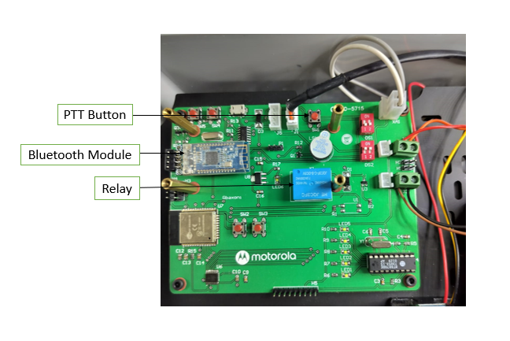

Fig2